Fencing Coaches’ Summer Workshop 2017 with Ildemaro Sanchez

A partnership project between FENB & Damocles

at Damocles Fencing Club, 800 St. Mary’s St., Fredericton

July 29: 1:00 pm to 5:00 pm and July 30: 9:00 am to 4:30 pm, 2017

***********************************************************************

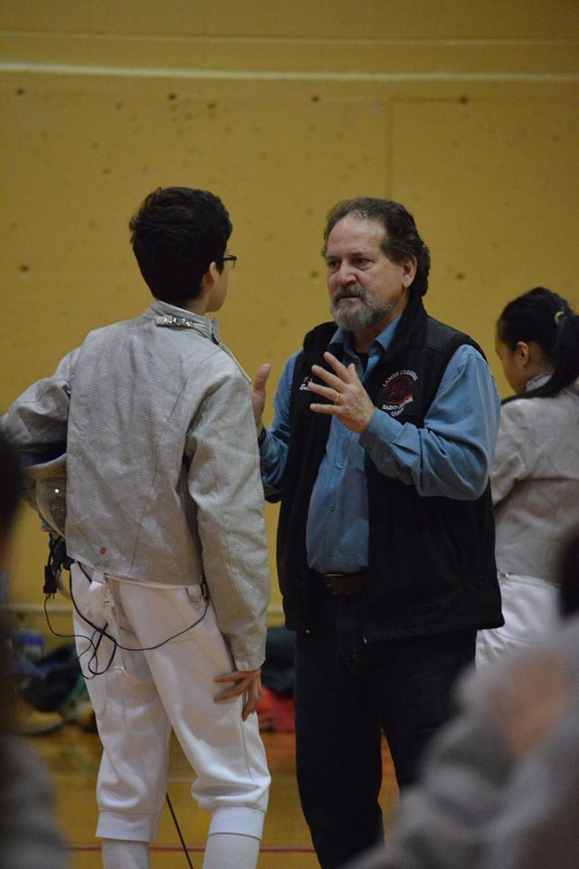
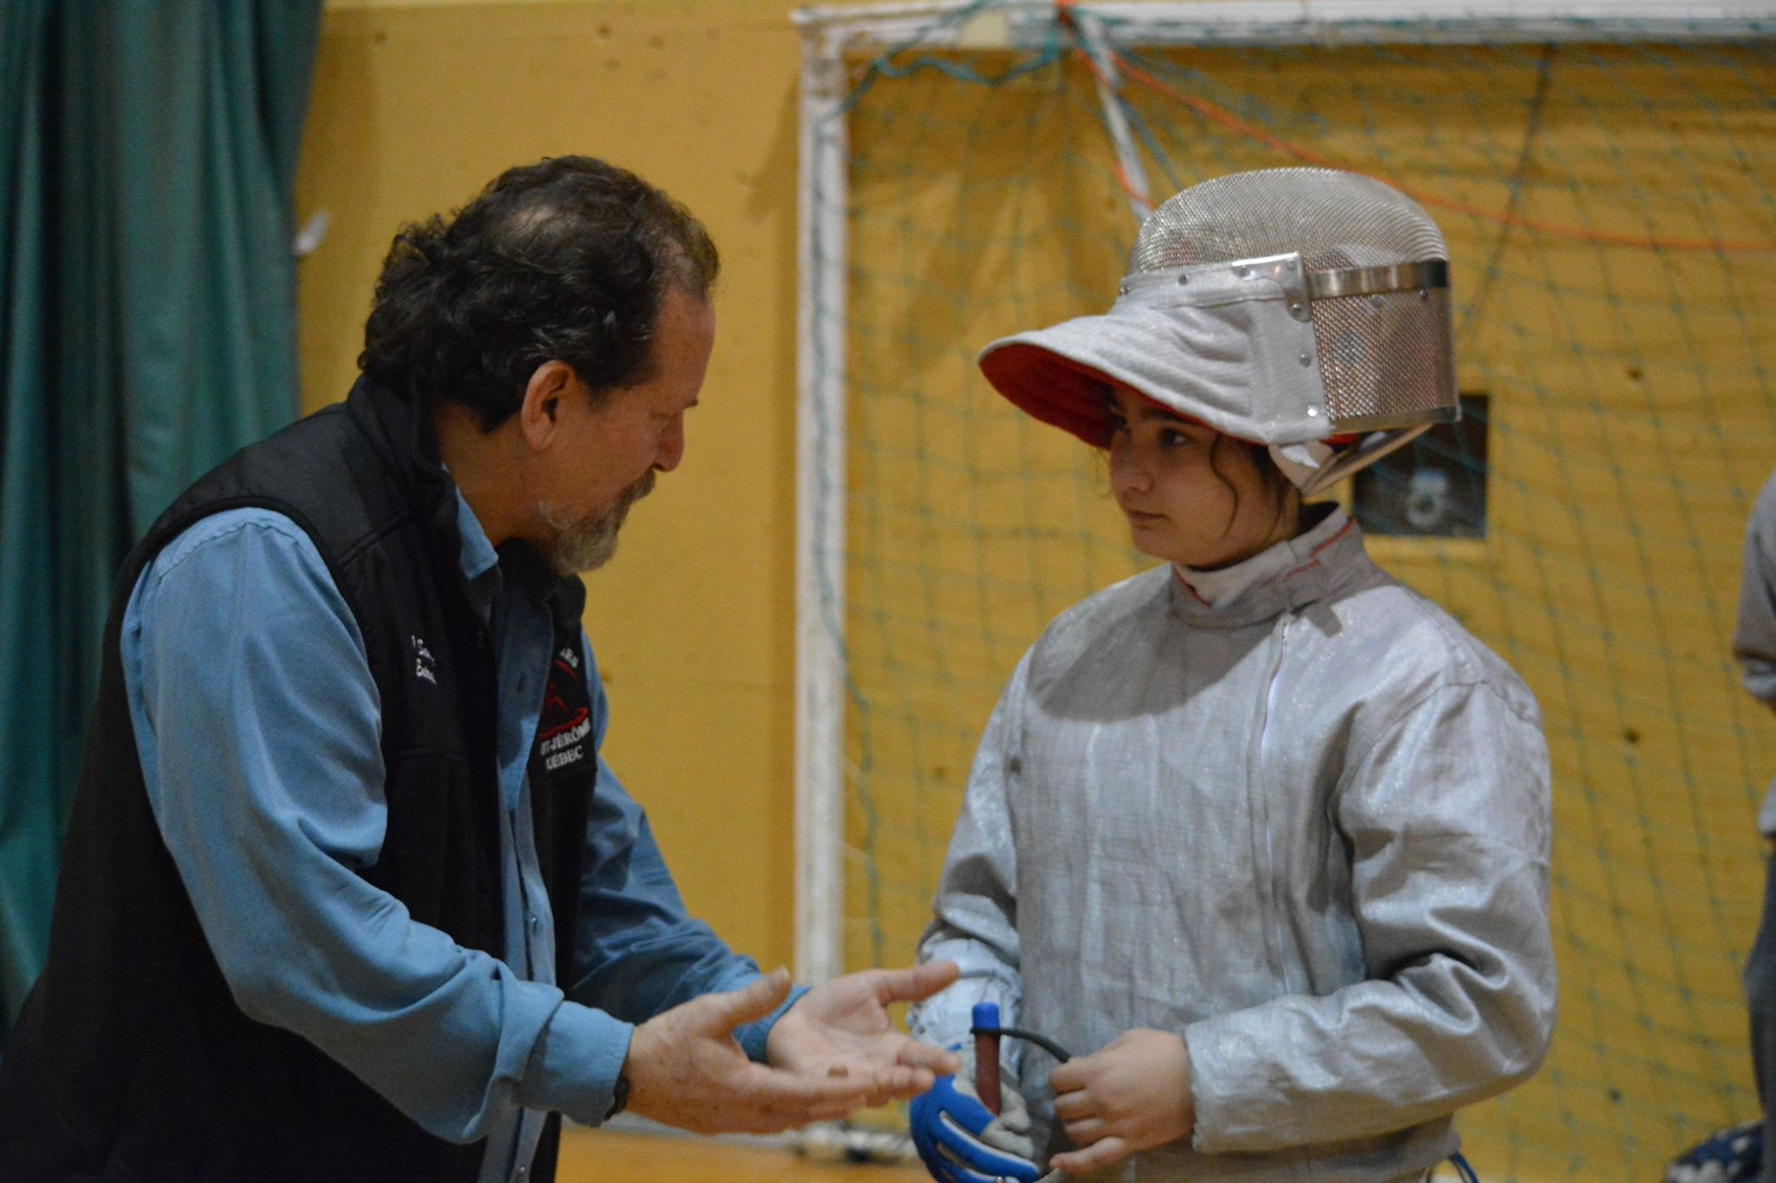

Maître Ildemaro Sanchez has trained as a physical education teacher (Venezuela) and fencing master (INSEP-Paris, France) and completed a Master’s degree in strategic planning (Venezuela). He represented Venezuela at the 1984 Olympics, and has coached at club, provincial and national levels. He is responsible for coaching development in Quebec.

Workshop Description: Coaches will learn how to integrate basic tactics (distance play, timing and game logic) into group drills and individual lessons for fencers working at the fundamentals and learn-to-train stages of fencer development.

Pre-requisites:
- Coaches must be comfortable with basic technical repertoire (footwork & bladework) to orange level.
- Coaches must be current members of FENB & CFF.

Fee: before June 15 = $75 after June 15 = $95

To register: Return registration form & pay fee by cheque to: Damocles Fencing Club
or by e-transfer to: damoclesfencing@gmail.com

Fencing Coaches’ Summer Workshop 2017 with Ildemaro Sanchez

Registration Form

Name: ______________________________________

Home address: _______________________________ Postal Code: _________________

E-mail address: _______________________________ Home phone: ________________

Dates: July 29-30 Fee* (before June 15) = $75.00 Fee* (after June 15) = $95.00

*Cancellation policy: $20 of fees will be non-refundable for cancellations

Club affiliation: ____________________________________

Which age groups do you work with: under 13____, 14 to 18____, adult____

Which is your primary weapon? Foil ____ Epee ____ Sabre ____

Emergency Contact: (daytime)

Name: __________________________________ Phone 1: _________________
Phone 2: _________________
Fencer’s Medicare #: ______________________________

Participant Agreement: Please read carefully and sign below:
I understand that there is potential risk for injury inherent in fencing, as in all sports. These include but are not limited to:
- muscular injuries resulting from vigorous exertion and rapid changes of direction of movement.
- bruises resulting from hits received during fencing.
- injuries resulting from my failure to properly use the fencing equipment.
- injuries resulting from the breakage of a fencing sword or failure of protective equipment,
- additional risks associated with my travel to and from the fencing event.

Personal protective equipment: I understand that it is mandatory to wear a properly fitting fencing mask, underarm plastron, breast protector for females, fencing jacket, glove with gauntlet, and long pants of robust material, all of which must be in good repair.
Safety rules: I understand that rules have been established for safe conduct in training that I must follow and that the camp organizers have tried to create a safe and controlled environment for participation.

Release: I am participating voluntarily at the Damocles Fencing Club and I agree to abide by the rules and guidelines for conduct established by the club leaders and to participate to the best of my ability. I agree to accept the risks and be responsible for any injury, equipment damage or other loss that I might incur as a direct or indirect result of my participation. I agree to release the Damocles Fencing Club, Fencing-Escrime NB and their respective directors, staff, and coaches, of all responsibility for such injury, loss or damage.

Acknowledgement: I have read this agreement and understand its significance.

Signature of Participant (If participant is under 18, Signature of Parent or Guardian): ______________________

