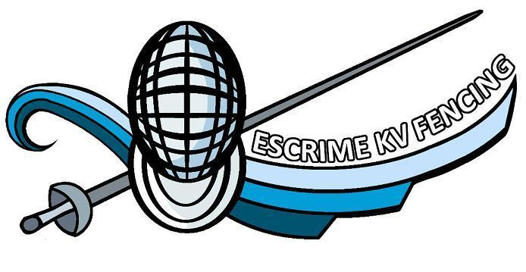
Summer Foil Fencing Camp
Date: Monday July 17th- Friday July 21st, 2017
Time: 9:00 a.m. to 4:00 p.m.
European Coach Maître d’armes Xavier Boulet from Switzerland .2-time bronze medalist, Fencing Master World Championships.
Location: 250 Quispamsis Road (École des Pionniers) Quispamsis, NB E2E 0R7
Cost: $160.00 per participants
Deadline to register is June 28th, 2017
Email:diraiche@outlook.com
Payment and Registration must arrive no later than June 28th, 2017 to ensure a spot.
Bring snacks and lunch. We have access to 2 microwaves. Indoor sneakers, water bottle and electric fencing gear.

