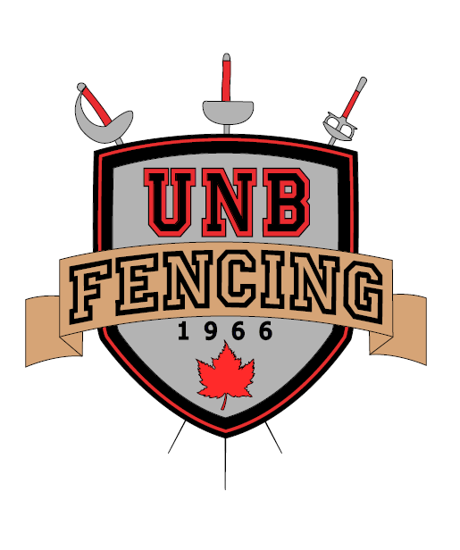

Epee Training Clinic and Epee Circuit #2

November 6th, 2016, 8:00am-5:00pm

UNB Currie Center, Recreation Gym

Fredericton, NB
The UNB Fencing Club and FENB invite you to participate in a one-day Epee Training Clinic and Tournament on the 6th of November, 2016. This clinic is open to all epeeists who have at least already completed their yellow armband or equivalent (ask your coach if you aren’t sure), focusing more on fencers intending to compete at the national level this season or next season. It will include both general group lessons and one-on-one lessons with the clinic coaches.
The head coach for this clinic is Rick Gosselin of the Fundy Fencing Club. Rick has been a staple of Epee in New Brunswick for decades, coaching NB teams to Gold (2003) and Bronze (2007) medals at the Canada Games. He is an NCCP level 3 coach.
To assist Rick, David Themens and Patrick Bradley will also be coaching at the clinic. David is a competitive epeeist, currently serving as the Advanced Epee Coach at the UNB Fencing Club. Patrick is also a competitive epeeist, currently serving as Damocles’ Epee Coach.
The cost of this clinic and tournament is 30$ (total). Participants should have a valid CFF membership in order to participate. Lunch will not be provided and is thus the responsibility of the fencer. A few participants will be picking up lunch at local restaurants, please make arrangements with us in advance if you would like us to pick up something for your fencer. To register, simply send an email to fencing.unb@gmail.com with your fencer’s name, year-of-birth, CFF number, and experience level. Registration for the clinic is limited to 20 participants on a first-come, first-served basis.
The clinic schedule can be found below. The day will end with a CFF-sanctioned Epee Tournament. Registration for this tournament is included in the clinic registration. There is no registration limit for this tournament. The cost for only participating in the tournament is 10$.
Parents are welcome to observe during the afternoon tournament.
Activity | Time Range
Stretching and Warm-up Games | 8:00am - 8:45am
Group Lessons/Line Drills | 8:45am - 10:30am
Directed Bouting and One-on-One Lessons | 10:30am - 11:00am
Focused Skill Development | 11:00am - 12:00pm
Lunch | 12:00pm - 12:45pm
Tournament Check-in | 12:45pm - 1:00pm
Tournament | 1:00pm - 5:00pm

